

**NAME: AMY TANYA WANJALA**

**ADM NO: BSE-05-0178/2022**

**CAT TWO**

**OBITUARY WEB APP DOCUMENTATION**

**Introduction**

The obituary web app is used to submit and view obituaries from various authors. It is built by the Django framework and MySQL languages. It is a simple user interface with good visibility, giving the user knowledge of what to do at any given time.

**Instructions for use**

1. The necessary equipment for using it include a good laptop and a web browser.
2. Enter data to their corresponding labels and press submit. When the data is submitted, you will receive a success message.
3. To see the data in the table, press retrieve.
4. Press Share on Facebook to share the data on Facebook.
5. Press Share on Twitter to share the data on Twitter.

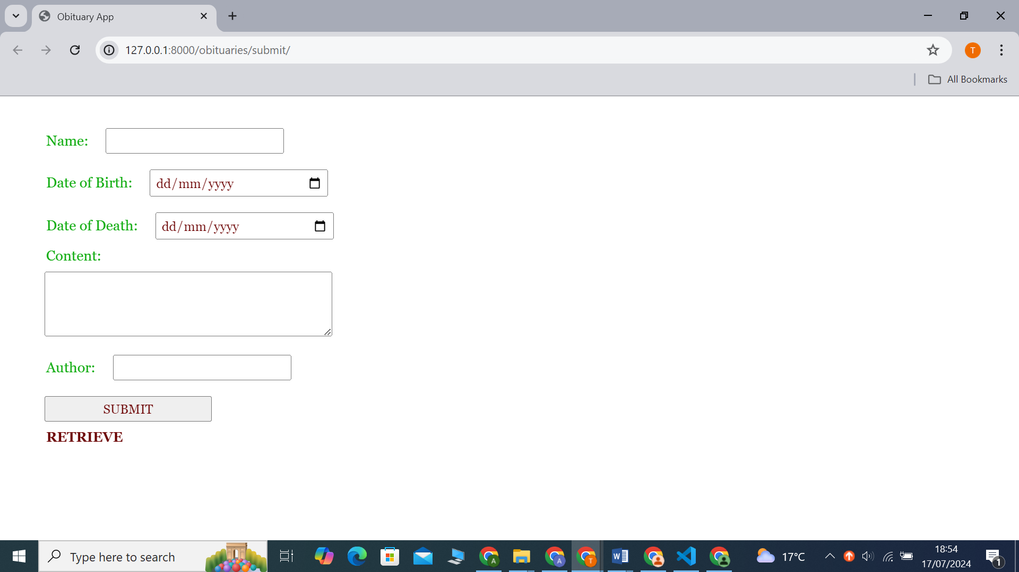

Figure : Obituary form user interface

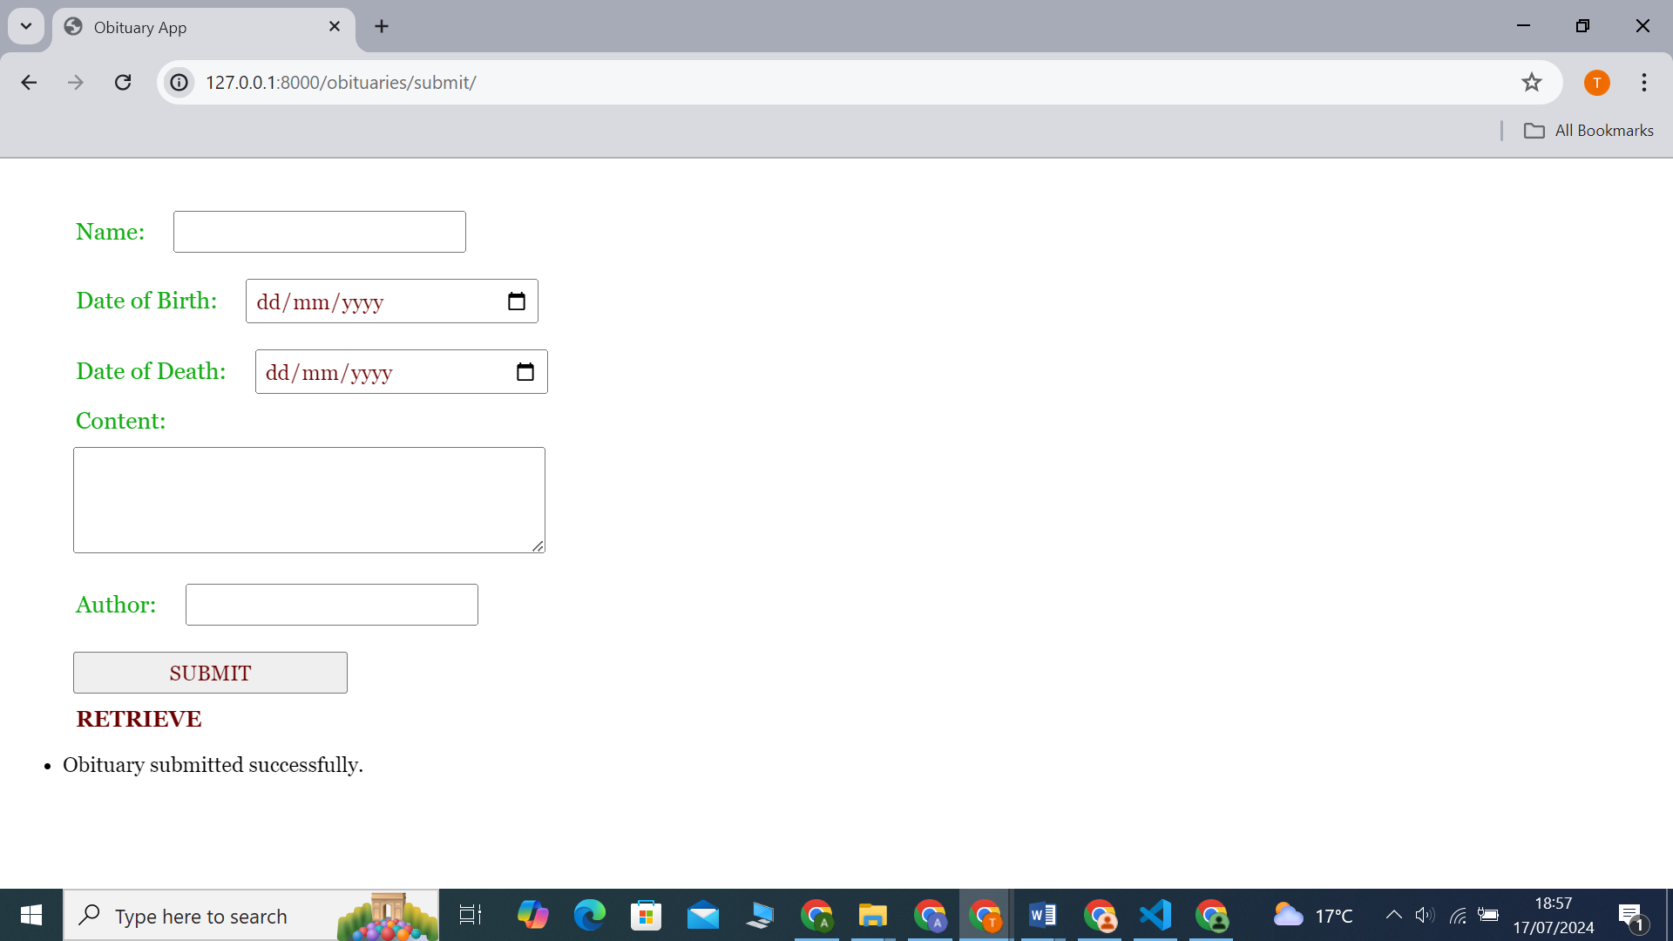

Figure : Success message

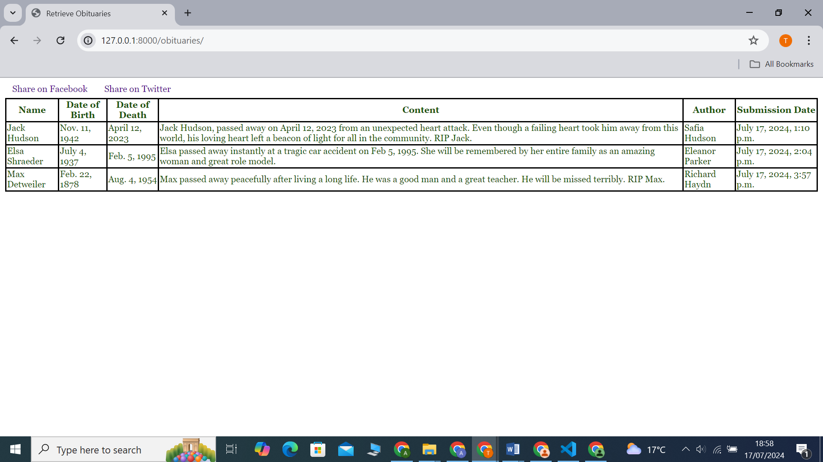

Figure : Data in database

**Example**

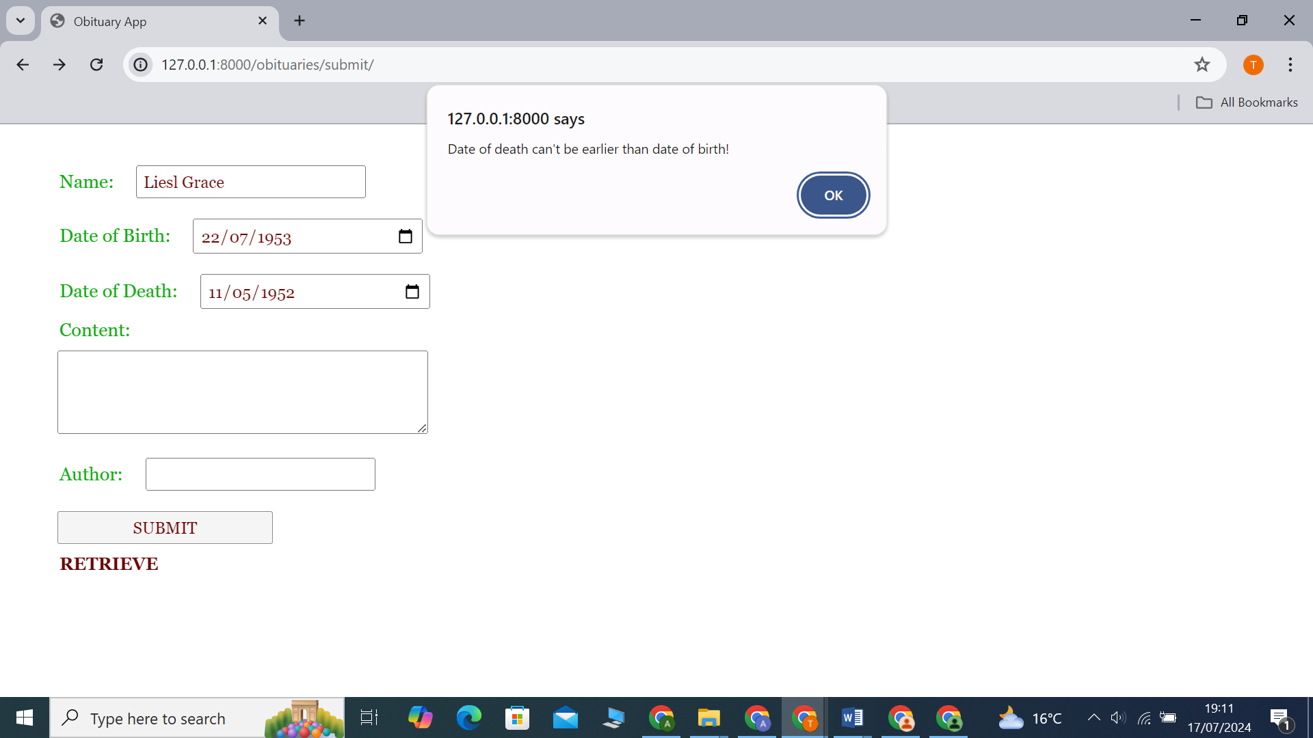

Error

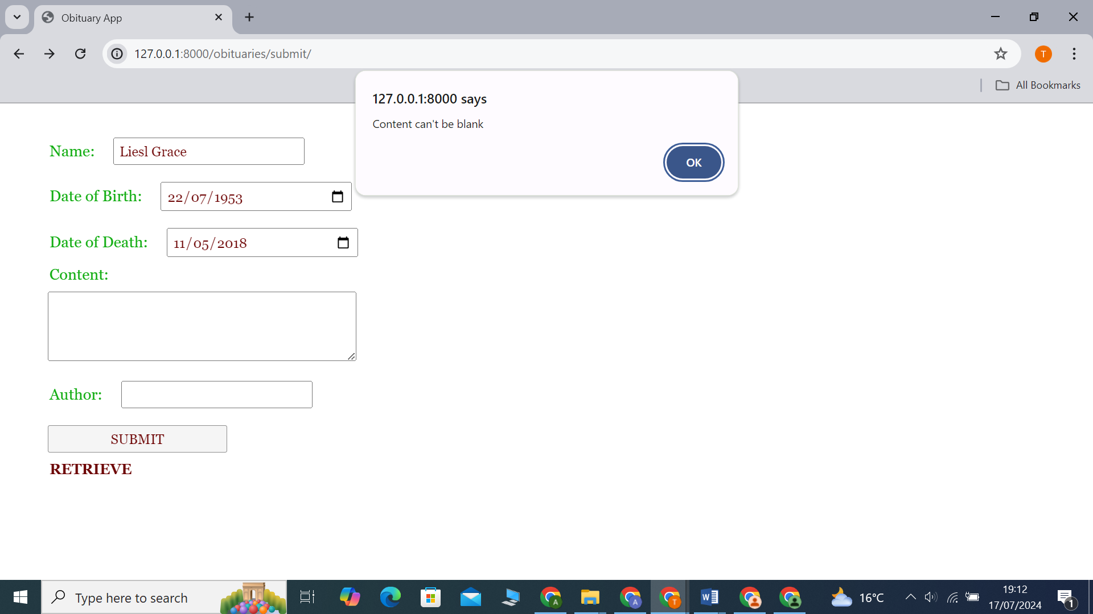

Error

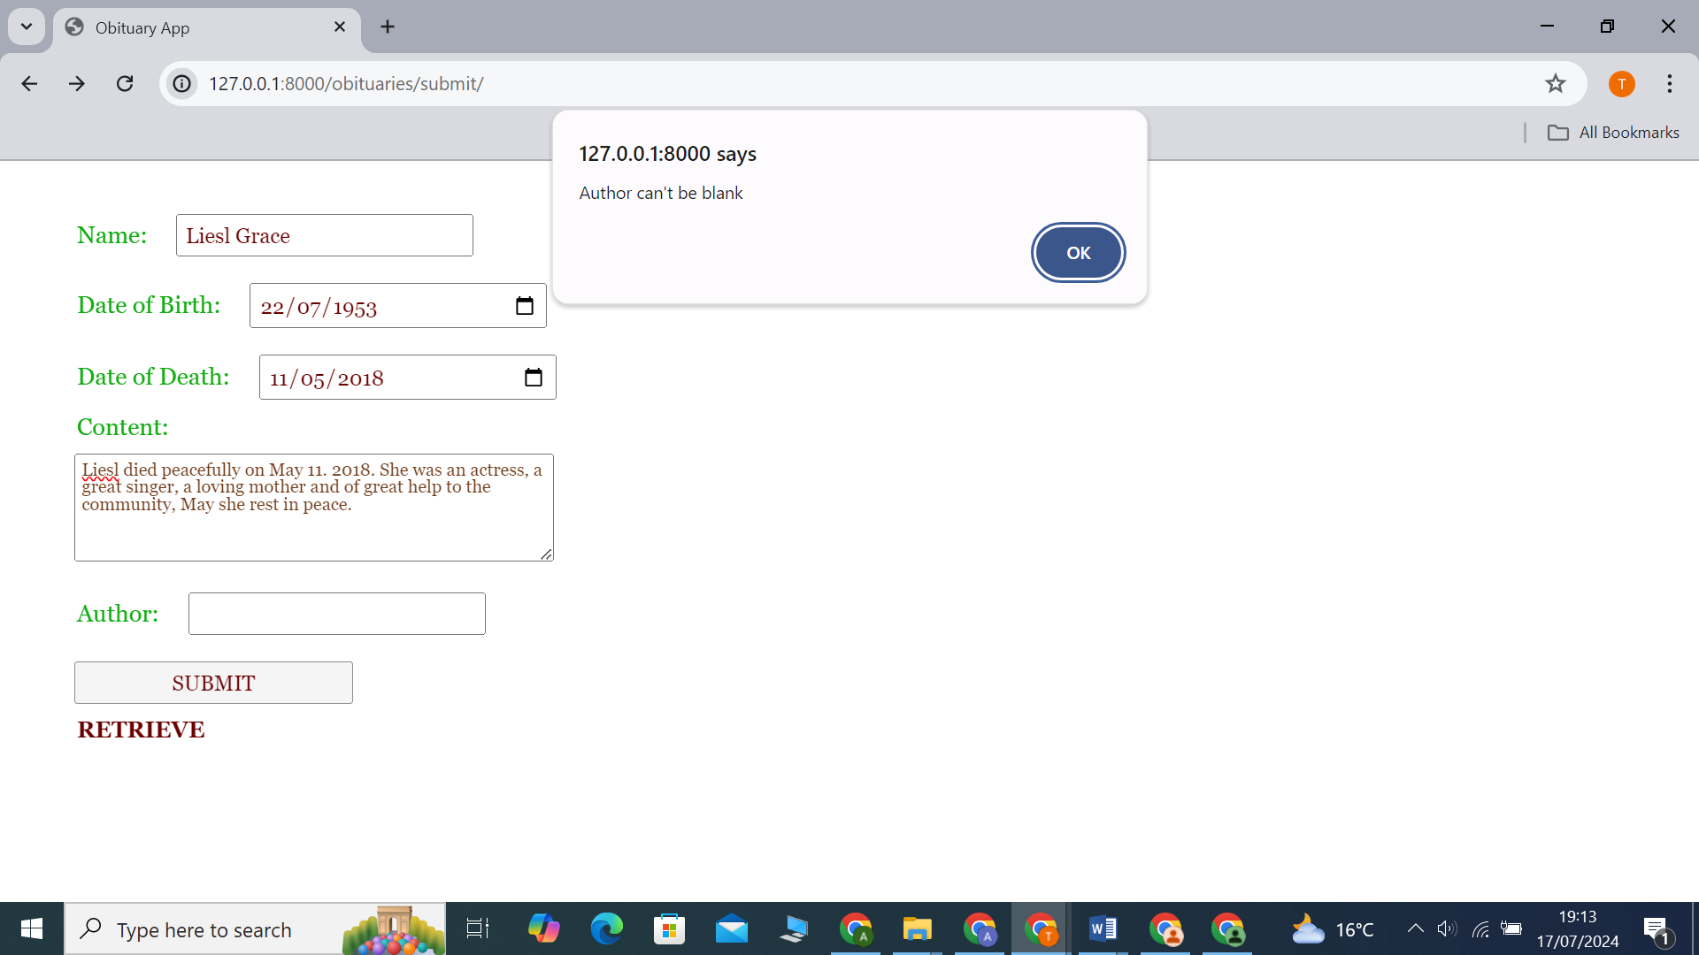

Error



Figure :Successful submission

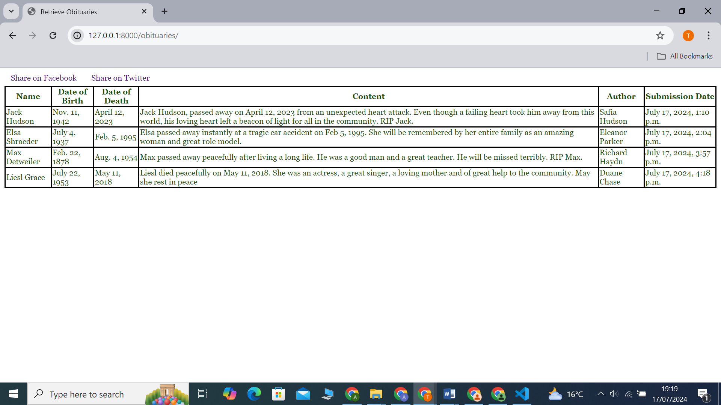

Figure : Data retrieval when you press retrieve button

**OBITUARY PLATFORM DATABASE**

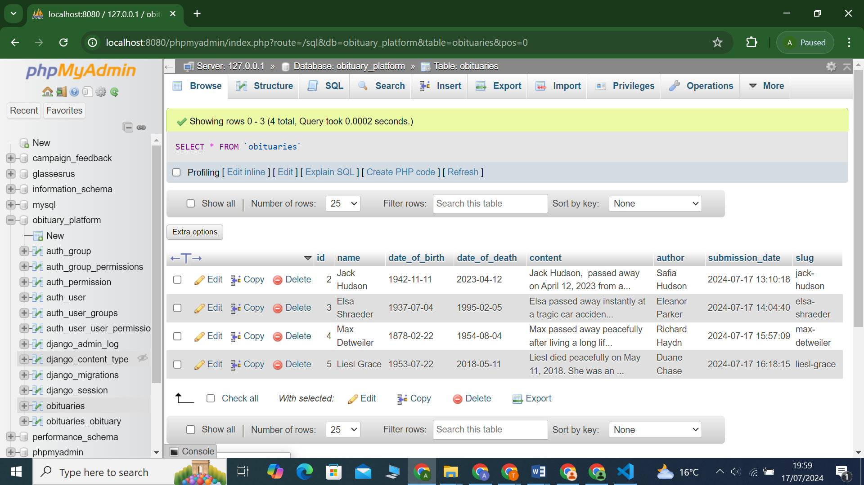

Figure : Obituary table